COMP 2714

aSSIGNMENT 4

NORMALIZATION RELATIONAL MODEL

**QUESTION 1**

**UNF**

**orderForm**(OrdNo, OrdDate, OrdName,OrdStreet, OrdCity, OrdState, OrdZip, CustNo, CustFirstName,CustLastName,CustStreet, CustCity, CustState, CustZip, EmpNo, EmpFirstName, EmpLastName, [ProdNo, Product, SuppNo, Supplier,Qty, Price, Amount], TotalAmount)

**1NF: Resolve the repetitive groups**

**orderForm**(OrdNo, OrdDate, OrdName, OrdStreet, OrdCity, OrdState, OrdZip,CustNo, CustFirstName, CustLastName,CustStreet, CustCity, CustState, CustZip, EmpNo,EmpFirstName, EmpLastName, TotalAmount)

**OrderDetails**(ProdNo, OrderNo(FK), SuppNo, Product, Supplier, Qty, Price, Amount)

**2NF - Resolve partial Dependency**

**Assumptions:The price does not depend on the supplier. It is dependent on the product. The supplier is merely just a tool for the product to be distributed.**

**Order**(OrdNo, OrdDate, OrdName, OrdStreet, OrdCity, OrdState, OrdZip, EmpNo, EmpFirstName, EmpLastName, CustNo, CustFirstName, CustLastName, CustStreet, CustCity, CustState, CustZip, TotalAmount)

**ProductDetails**(ProdNo, Product, Price)

**OrderDetails**(ProdNo[FK],Product, SuppNo, Supplier, Qty, Amount)

**3NF - Resolve transitive dependency**

**Assumptions: There can only be one employee managing one order. You cannot have multiple employees managing the same order. As for the supplier, the supplier can supply multiple products, but that product can only be supplied by them, and no other supplier.**

**Order(**OrdNo, EmpNo[FK], CustNo[FK], OrdDate, OrdName, OrdStreet, OrdCity, OrdState, OrdZip, TotalAmount)

**Customer**(CustNo, CustFirstName, CustLastName, CustStreet, CustCity, CustState, CustZip)

**OrderDetails**(OrdNo[FK], ProdNo[FK], Qty, Amount)

**ProductDetails** (ProdNo, SuppNo[FK], Product, Price)

**Employee**(EmpNo, EmpFirstName, EmpLastName)

**SupplierDetails**(SuppNo, Supplier,)

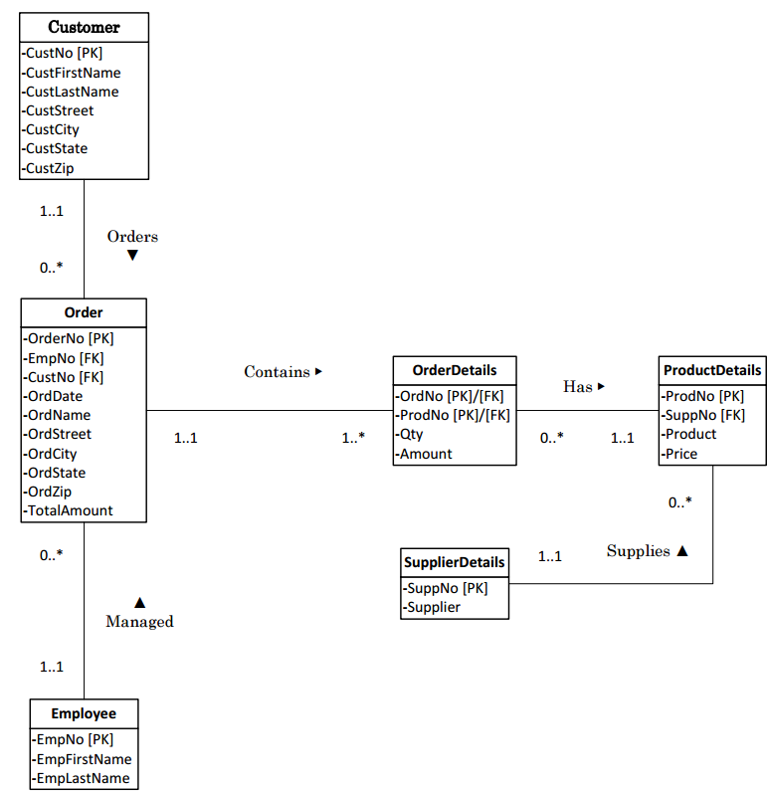**ER Diagram of Order Management System**

**QUESTION 2**

**UNF**

**Invoice**(InvoiceNo,CustNo,Name,Date,Address,OrderNo,[ProductNo,

Description,QtyOrd,QtyShip,QtyBack,UnitPrice,TotalPrice],

TotalAmount,Discount,AmountDue)

**1NF - Resolve the repetitive groups**

**Invoice**(InvoiceNo, OrderNo,CustNo, Name, Date, Address, TotalAmount,

Discount, AmountDue)

**InvoiceDetails**(InvoiceNo[FK], ProductNo, Description ,QtyOrd,QtyShip, QtyBack, UnitPrice, TotalPrice)

**2NF - Resolve partial Dependency**

**Assumptions:Discounts do not depend on the customer, but on the company. It is the company’s choice whether to give the customer a discount or not.**

**Invoice**(InvoiceNo, CustNo, Name, Address, OrderNo, Date, TotalAmount, Discount, AmountDue)

**Product**(ProducNo, Description, UnitPrice);

**InvoiceDetails**(InvoiceNo[FK], ProductNo, QtyOrd, QtyShip, QtyBack, UnitPrice, TotalPrice)

**3NF - Resolve Transitive Dependency**

**Invoice**(InvoiceNo, CustNo[FK], OrderNo, Date, TotalAmount, Discount)

**Customer**(CustNo, Name, Address)

**InvoiceDetails**(InvoiceNo[FK], ProdNo[FK], QtyOrder, QtyShip, QtyBack, TotalPrice)

**Product**(ProductNo, Description, UnitPrice)

**ER Diagram for Invoice Management System**

